图片水印嵌入和提取

1. 实验原理

LSB算法的核心思想是将水印信息（如文本、图像或二进制序列）嵌入到载体图像像素的最低有效位中。每个像素通常由8位二进制数表示，最低有效位（LSB）是其中最不重要的一位，其变化对像素值的影响最小。由于人类视觉系统对最低有效位的微小变化不敏感，因此嵌入水印后的图像在视觉上几乎与原始图像相同。

嵌入过程通常包括以下步骤：

读取载体图像和水印信息：将图像像素值转换为二进制形式，同时将水印信息（如文本）转换为二进制序列。

嵌入水印：将水印信息的每一位依次替换图像像素的最低有效位。

生成含水印图像：将修改后的二进制像素值重新转换为十进制，生成嵌入水印后的图像。

提取过程则是嵌入过程的逆过程：从含水印图像中提取每个像素的最低有效位，组合成水印信息。

二、代码实现

|  |
| --- |
| from PIL import Image |
| import os |
| import struct |
|  |
| def embed_watermark(carrier_path, watermark_path, output_path): |
|  |
| # 打开载体图片和水印图片 |
| carrier_img = Image.open(carrier_path).convert("RGB") |
| watermark_img = Image.open(watermark_path).convert("RGB") |
|  |
| # 检查载体图片是否足够大 |
| carrier_width, carrier_height = carrier_img.size |
| watermark_width, watermark_height = watermark_img.size |
| carrier_capacity = carrier_width * carrier_height * 3 # 每个像素3位 |
| watermark_size = watermark_width * watermark_height * 3 * 8 # 每个像素3字节×8位 |
|  |
| # 需要额外存储头信息（宽度4字节，高度4字节） |
| header_size = 8 * 8 # 8字节×8位/字节 |
|  |
| if watermark_size + header_size > carrier_capacity: |
| raise ValueError(f"载体图片太小，无法容纳水印图片。需要: {watermark_size + header_size} 位, 可用: {carrier_capacity} 位") |
|  |
| # 将水印图片转换为二进制字符串 |
| watermark_bin = "" |
| for pixel in watermark_img.getdata(): |
| for value in pixel: |
| watermark_bin += bin(value)[2:].zfill(8) |
|  |
| # 创建头信息（宽度和高度各4字节） |
| header_bin = bin(watermark_width)[2:].zfill(32) + bin(watermark_height)[2:].zfill(32) |
|  |
| # 合并头信息和水印数据 |
| full_data = header_bin + watermark_bin |
| total_bits = len(full_data) |
|  |
| # 将水印数据嵌入载体图片 |
| carrier_data = list(carrier_img.getdata()) |
| new_data = [] |
| data_index = 0 |
|  |
| for pixel in carrier_data: |
| if data_index >= total_bits: |
| new_data.append(pixel) |
| continue |
|  |
| r, g, b = pixel |
| # 嵌入R通道 |
| r = (r & 0xFE) | int(full_data[data_index]) |
| data_index += 1 |
|  |
| # 如果还有数据，嵌入G通道 |
| if data_index < total_bits: |
| g = (g & 0xFE) | int(full_data[data_index]) |
| data_index += 1 |
| else: |
| new_data.append((r, g, b)) |
| continue |
|  |
| # 如果还有数据，嵌入B通道 |
| if data_index < total_bits: |
| b = (b & 0xFE) | int(full_data[data_index]) |
| data_index += 1 |
|  |
| new_data.append((r, g, b)) |
|  |
| # 保存含水印的图片 |
| watermarked_img = Image.new("RGB", carrier_img.size) |
| watermarked_img.putdata(new_data) |
|  |
| # 确保使用PNG格式保存（无损） |
| if not output_path.lower().endswith('.png'): |
| output_path += '.png' |
|  |
| watermarked_img.save(output_path) |
| print(f"水印嵌入成功! 输出文件: {output_path}") |
| return watermarked_img |
|  |
| def extract_watermark(watermarked_path, output_path): |
|  |
| # 打开含水印图片 |
| watermarked_img = Image.open(watermarked_path).convert("RGB") |
| pixel_data = list(watermarked_img.getdata()) |
|  |
| # 提取头信息（宽度和高度各4字节 = 32位） |
| header_bin = "" |
| bits_extracted = 0 |
| header_bits_needed = 64 # 32位宽度 + 32位高度 |
|  |
| for pixel in pixel_data: |
| r, g, b = pixel |
|  |
| # 提取R通道的LSB |
| header_bin += str(r & 1) |
| bits_extracted += 1 |
| if bits_extracted >= header_bits_needed: |
| break |
|  |
| # 提取G通道的LSB |
| header_bin += str(g & 1) |
| bits_extracted += 1 |
| if bits_extracted >= header_bits_needed: |
| break |
|  |
| # 提取B通道的LSB |
| header_bin += str(b & 1) |
| bits_extracted += 1 |
| if bits_extracted >= header_bits_needed: |
| break |
|  |
| if len(header_bin) < header_bits_needed: |
| raise ValueError("无法提取完整的头信息") |
|  |
| # 解析宽度和高度 |
| width_bin = header_bin[:32] |
| height_bin = header_bin[32:64] |
|  |
| try: |
| width = int(width_bin, 2) |
| height = int(height_bin, 2) |
| except: |
| raise ValueError("无法解析水印尺寸信息") |
|  |
| print(f"提取的水印尺寸: {width}×{height} 像素") |
|  |
| # 计算水印数据总位数 |
| watermark_bits_needed = width * height * 3 * 8 |
|  |
| # 提取水印数据（跳过已读取的头信息） |
| watermark_bin = "" |
| current_index = bits_extracted // 3 # 已经处理的像素数 |
| if bits_extracted % 3 != 0: |
| current_index += 1 |
|  |
| bits_extracted = 0 |
|  |
| # 继续提取剩余像素 |
| for i in range(current_index, len(pixel_data)): |
| if bits_extracted >= watermark_bits_needed: |
| break |
|  |
| r, g, b = pixel_data[i] |
|  |
| # 提取R通道 |
| watermark_bin += str(r & 1) |
| bits_extracted += 1 |
| if bits_extracted >= watermark_bits_needed: |
| break |
|  |
| # 提取G通道 |
| watermark_bin += str(g & 1) |
| bits_extracted += 1 |
| if bits_extracted >= watermark_bits_needed: |
| break |
|  |
| # 提取B通道 |
| watermark_bin += str(b & 1) |
| bits_extracted += 1 |
| if bits_extracted >= watermark_bits_needed: |
| break |
|  |
| # 将二进制数据转换为像素值 |
| watermark_data = [] |
| for i in range(0, min(len(watermark_bin), watermark_bits_needed), 8): |
| if i + 8 > len(watermark_bin): |
| break |
| byte = watermark_bin[i:i+8] |
| watermark_data.append(int(byte, 2)) |
|  |
| # 确保数据长度匹配图像尺寸 |
| expected_pixels = width * height |
| expected_values = expected_pixels * 3 |
| if len(watermark_data) < expected_values: |
| # 填充缺失数据为黑色 |
| watermark_data.extend([0] * (expected_values - len(watermark_data))) |
|  |
| # 创建水印图片 |
| watermark_img = Image.new("RGB", (width, height)) |
|  |
| # 将数据组织为RGB元组 |
| pixels = [] |
| for i in range(0, len(watermark_data), 3): |
| r = watermark_data[i] if i < len(watermark_data) else 0 |
| g = watermark_data[i+1] if i+1 < len(watermark_data) else 0 |
| b = watermark_data[i+2] if i+2 < len(watermark_data) else 0 |
| pixels.append((r, g, b)) |
|  |
| watermark_img.putdata(pixels[:expected_pixels]) |
|  |
| # 确保使用PNG格式保存 |
| if not output_path.lower().endswith('.png'): |
| output_path += '.png' |
|  |
| watermark_img.save(output_path) |
| print(f"水印提取成功! 输出文件: {output_path}") |
| return watermark_img |
|  |
| if __name__ == "__main__": |
|  |
| carrier_image = "example1.png" |
| watermark_image = "example2.png" |
| watermarked_image = "example_im.png" |
| extracted_watermark = "extracted_example.png" |
|  |
| try: |
| # 嵌入水印 |
| watermarked = embed_watermark(carrier_image, watermark_image, watermarked_image) |
|  |
| # 提取水印 |
| extracted = extract_watermark(watermarked_image, extracted_watermark) |
| extracted.show() |
|  |
| except Exception as e: |
| print(f"错误: {e}") |

（参考：https://blog.csdn.net/qq_41821067/article/details/111062871）

三、实验结果



载体图片：

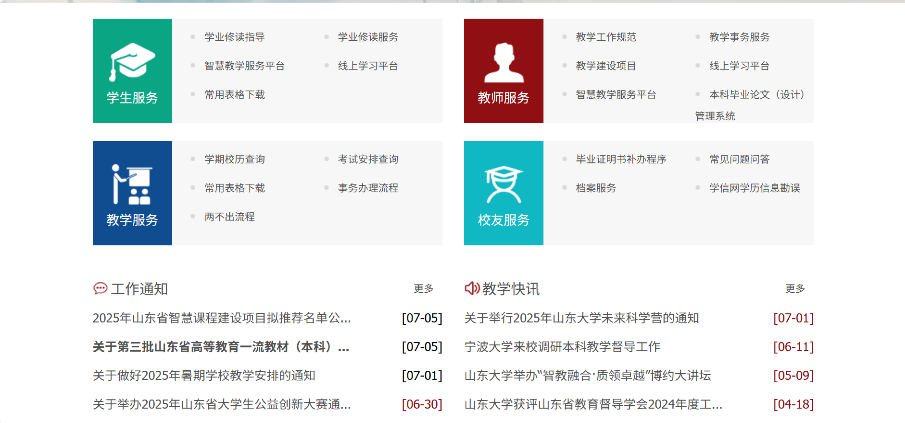

水印图片：



嵌入水印的图像：

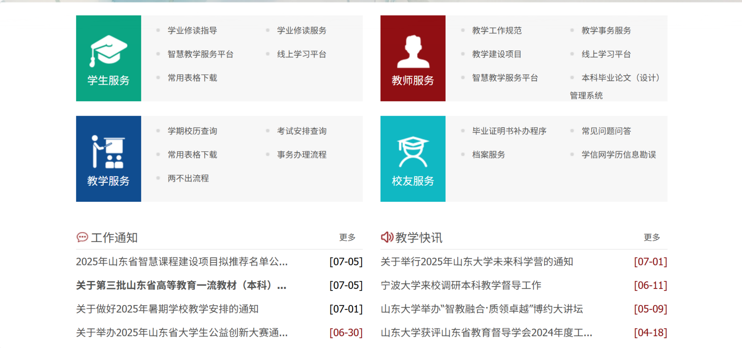

提取出的水印：



1. 鲁棒性测试
2. 翻转：

水印图片：

嵌入水印的图像：

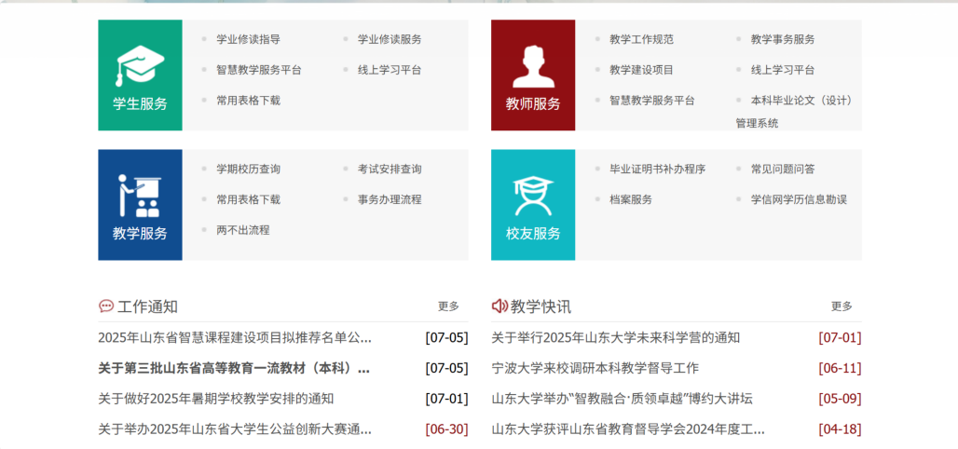

提取出的水印：



1. 平移：

水印图片：



嵌入水印的图像：

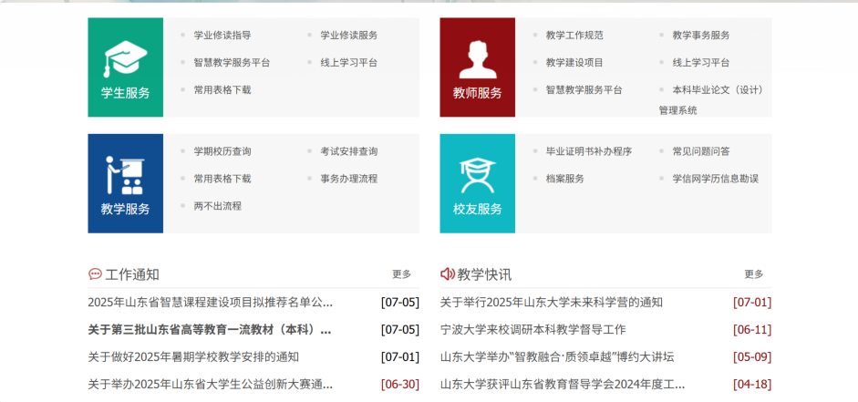

提取出的水印：



1. 截取：

水印图片：



嵌入水印的图像：

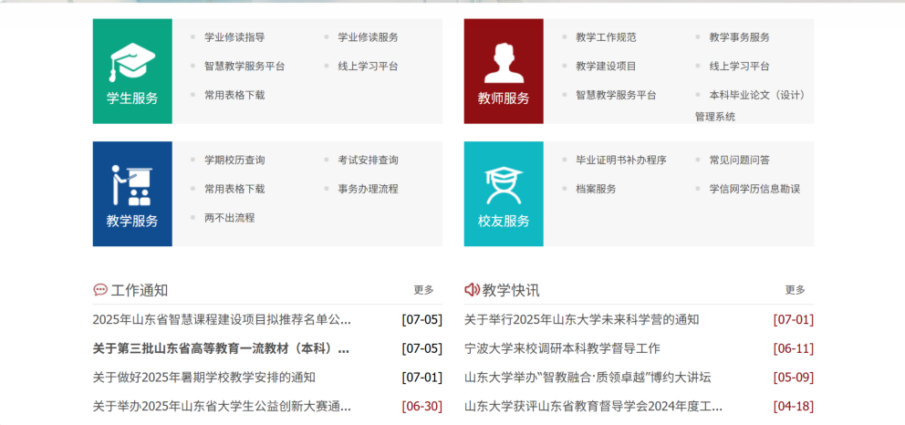

提取出的水印：



1. 调整对比度：

水印图片：

嵌入水印的图像：

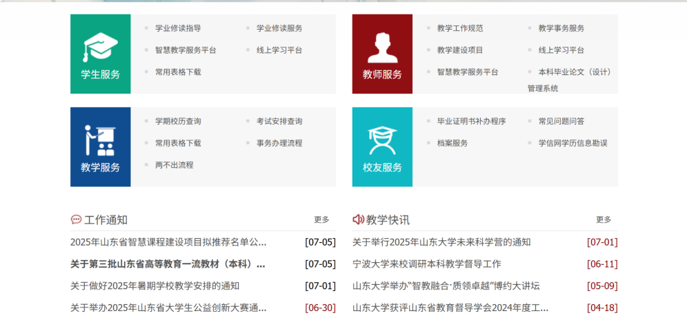

提取出的水印：

